**Pratik Rathi**

**Cloud SQL and GCS**

**Q1) Host a static website using GCS bucket.**

Steps:

1. Create a new Bucket
2. Upload your HTML File
3. Click on the more action menu on the files you want to host i.e. index.html
4. Select Edit permission and then click on ‘Add item’
5. Add a permission by selecting user for Entity, allUsers for the name and reader for the access and then click save.
6. You will get a public link. Click on that and you will be able to view your index.html

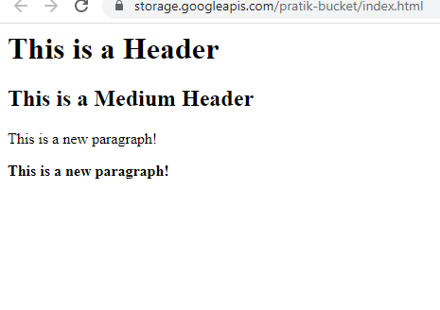

**Q2) Create a folder structure in the bucket as follows (manually) :**

**-folder1**

**- file1.txt**

**-folder2**

**-file2.txt**

**Download the entire folder (folder1) on the local (cloud shell or vm) using python3 with standard library.**

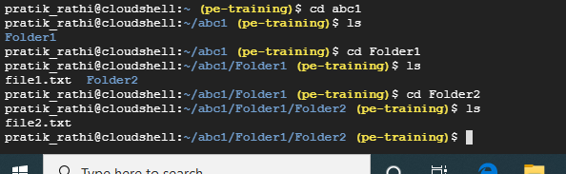

**Code:**

